**T.Y.B.Sc. COMPUTER SCIENCE SEMESTER: V**

Lab Manual

**Subject Code: USCSP501 Subject Name: Artificial Intelligence**

**Course Writer: Prof. Hasan Phudinawala**



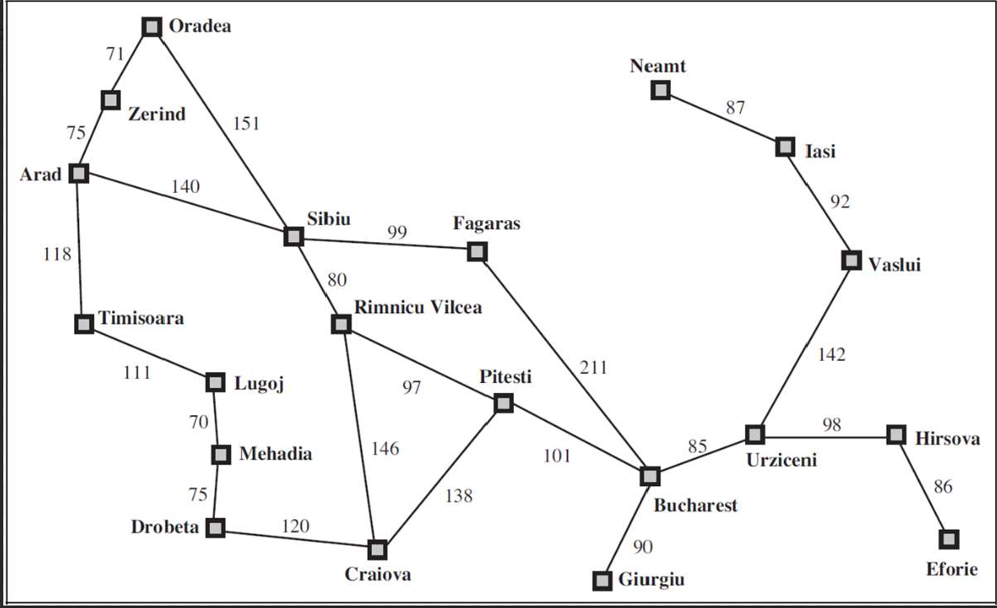

**PRACTICAL 1**

A. **Aim: Implement Breadth First Search Algorithm Dataset**: RMP.py File

**Requirement:** RMP.py, Python IDLE

**Diagram:**

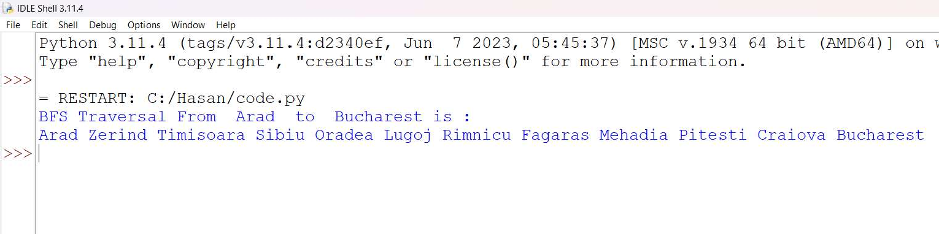

1. **Code: Implement the Breadth First Search algorithm to solve a given problem.**

import queue as Q

from RMP import dict_gn start = 'Arad'

goal = "Bucharest" result=''

def BFS(city,cityq,visitedq): global result

if city==start:

result = result + "" + city

for eachcity in dict_gn[city].keys(): if eachcity==goal:

result = result + " " + eachcity return

if eachcity not in cityq.queue and eachcity not in visitedq.queue: cityq.put(eachcity)

result = result + " " + eachcity visitedq.put(city) BFS(cityq.get(),cityq,visitedq)

def main():

cityq = Q.Queue() visitedq = Q.Queue() BFS(start,cityq,visitedq)

print("BFS Traversal From ", start," to " , goal, "is :") print(result)

main()

**Output:**



1. **Code: Implement the Iterative Depth First Search algorithm to solve the same problem.**

import queue as Q

from RMP import dict_gn start = "Arad"

goal = "Bucharest" result = ""

def DLS(city,visitedstack,startlimit,endlimit): global result

found = 0

result = result + city + " " visitedstack.append(city) if city == goal:

return 1

if startlimit == endlimit: return 0

for eachcity in dict_gn[city].keys(): if eachcity not in visitedstack:

found = DLS(eachcity,visitedstack,startlimit+1,endlimit) if found:

return found

def IDDFS(city,visitedstack,endlimit): global result

for i in range(0,endlimit): print("Seaching at Limit:", i)

found = DLS(city,visitedstack, 0 , i) if found:

print("Found") break

else:

print("Not Found!") print(result)

print(" ") result="" visitedstack = []



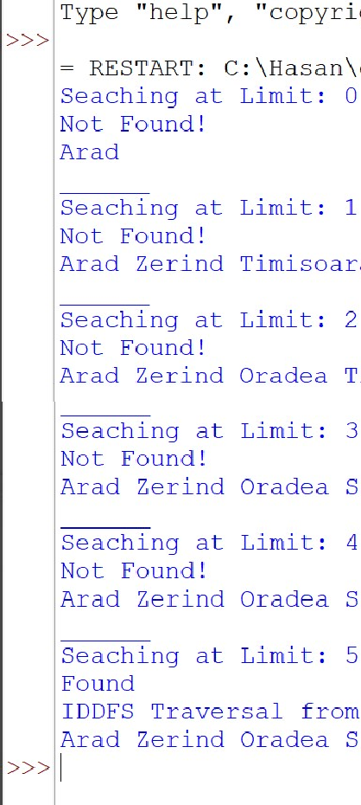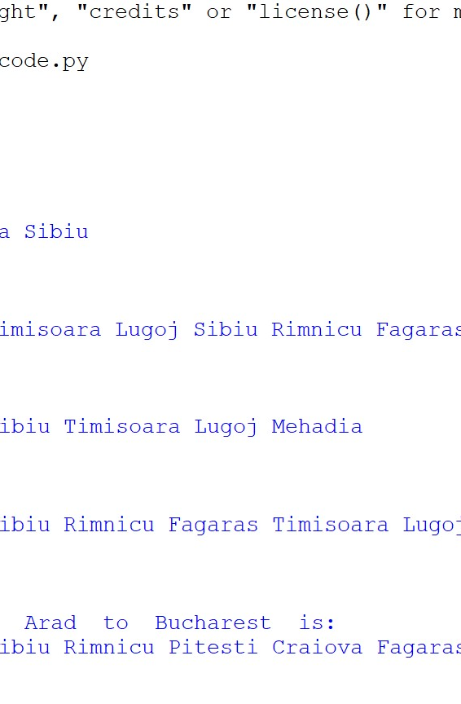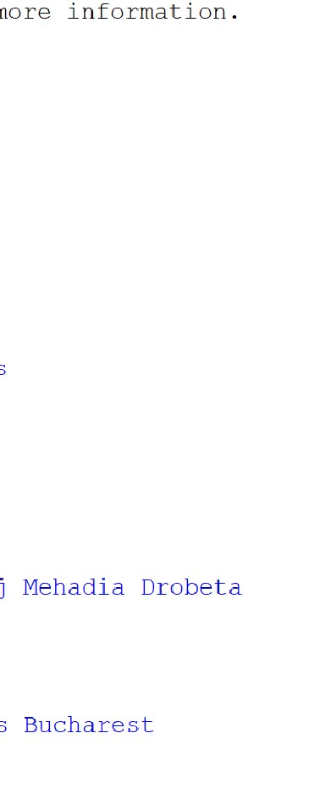

def main(): visitedstack = []

IDDFS(start,visitedstack,9)

print("IDDFS Traversal from ", start, " to ",goal," is:") print(result)

main()

**Output:**



**PRACTICAL 2**

**AIM: A* Search and Recursive Best-First Search Dataset**: RMP.py File

**Code: Implement the A* Search algorithm for solving a pathfinding problem.**

import queue as Q

from RMP import dict_gn from RMP import dict_hn

start = 'Arad'

goal = 'Bucharest' result = ''

def get_fn(citystr): cities=citystr.split(",") hn=gn=0

for ctr in range(0, len(cities)-1): gn=gn+dict_gn[cities[ctr]][cities[ctr+1]]

hn=dict_hn[cities[len(cities)-1]] return(hn+gn)

def expand(cityq): global result

tot, citystr, thiscity=cityq.get() if thiscity==goal:

result=citystr+"::"+str(tot) return

for cty in dict_gn[thiscity]: cityq.put((get_fn(citystr+","+cty),citystr+","+cty,cty))

expand(cityq) def main():

cityq=Q.PriorityQueue() thiscity=start cityq.put((get_fn(start),start,thiscity)) expand(cityq)

print("The A* path with the total is: ") print(result)

main()

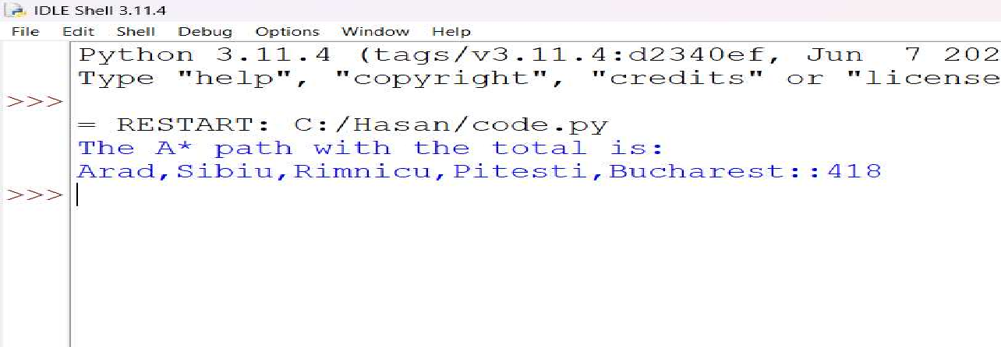

**Output:**

**Code: Implement the Recursive Best-First Search algorithm for the same problem.**

import queue as Q

from RMP import dict_gn from RMP import dict_hn

start = 'Arad'

goal = 'Bucharest' result = ''

def get_fn(citystr): cities=citystr.split(",") hn=gn=0

for ctr in range(0, len(cities)-1): gn=gn+dict_gn[cities[ctr]][cities[ctr+1]]

hn=dict_hn[cities[len(cities)-1]] return(hn+gn)

def printout(cityq):

for i in range(0, cityq.qsize()): print(cityq.queue[i])

def expand(cityq): global result

tot, citystr, thiscity = cityq.get() nexttot = 999

if not cityq.empty(): nexttot,nextcitystr,nextthiscity=cityq.queue[0]

if thiscity== goal and tot < nexttot:



result = citystr + "::" + str(tot) return

print("Expaded city ", thiscity)

print("second best f(n) ", nexttot)

tempq = Q.PriorityQueue() for cty in dict_gn[thiscity]:

tempq.put((get_fn(citystr+','+cty), citystr+','+cty, cty)) for ctr in range(1,3):

ctrtot, ctrcitystr ,ctrthiscity = tempq.get() if ctrtot < nexttot:

cityq.put((ctrtot, ctrcitystr,ctrthiscity)) else:

cityq.put((ctrtot, citystr, thiscity)) break

printout(cityq) expand(cityq)

def main(): cityq=Q.PriorityQueue() thiscity=start

cityq.put((999, "NA", "NA")) cityq.put((get_fn(start), start, thiscity)) expand(cityq)

print(result) main() **Output:**



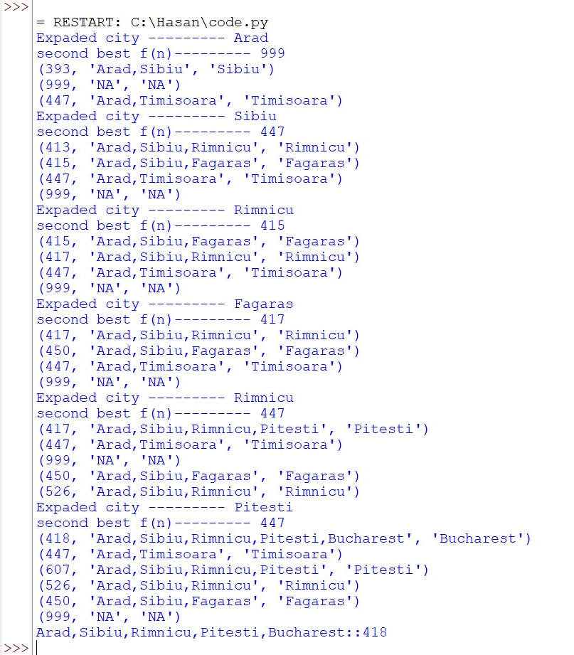



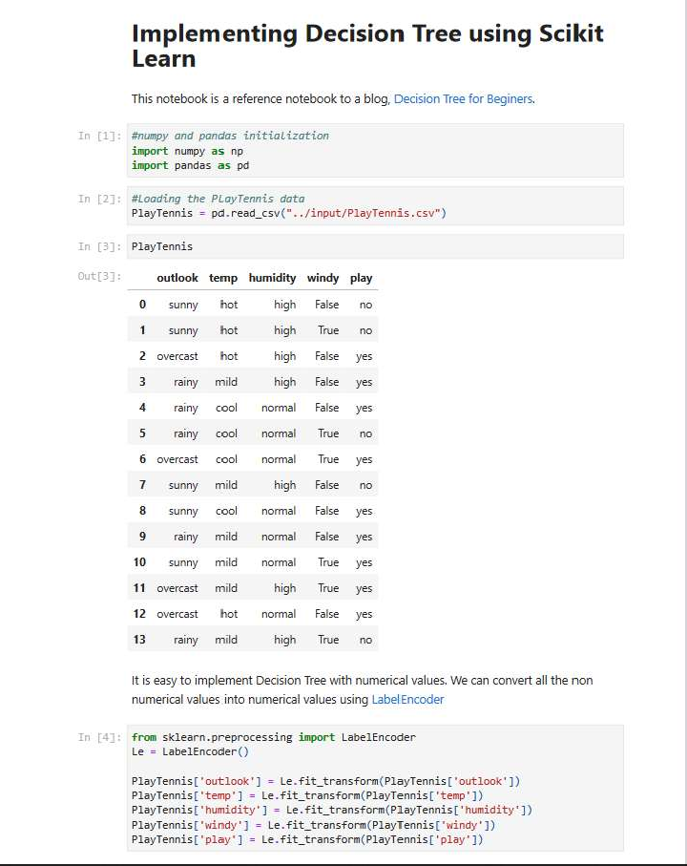

**PRACTICAL NO: 3**

**Aim: Implement the decision tree learning algorithm to build a decision tree for a given dataset. Evaluate the accuracy and efficiency on the test data set.**



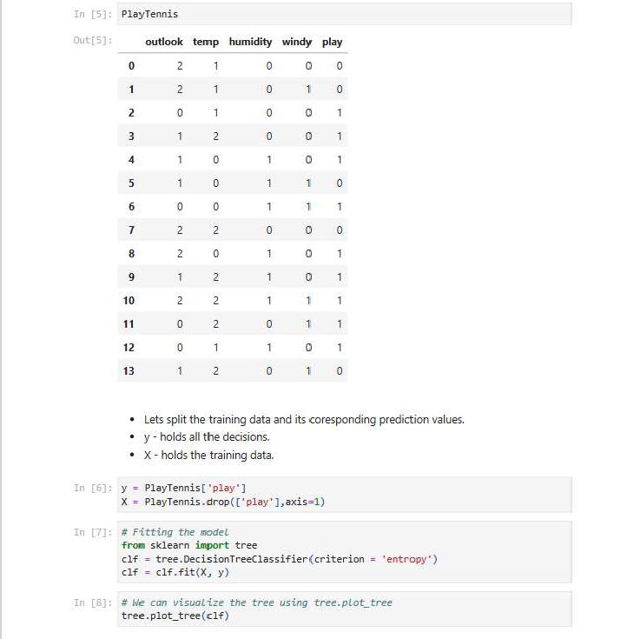



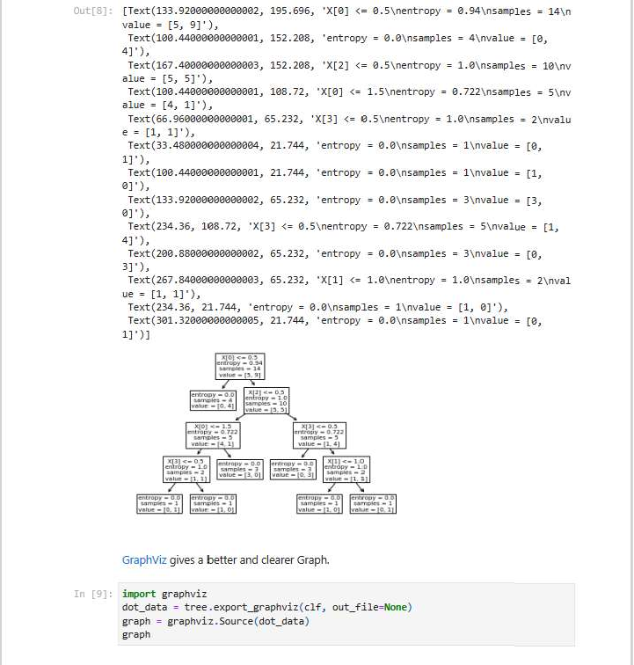



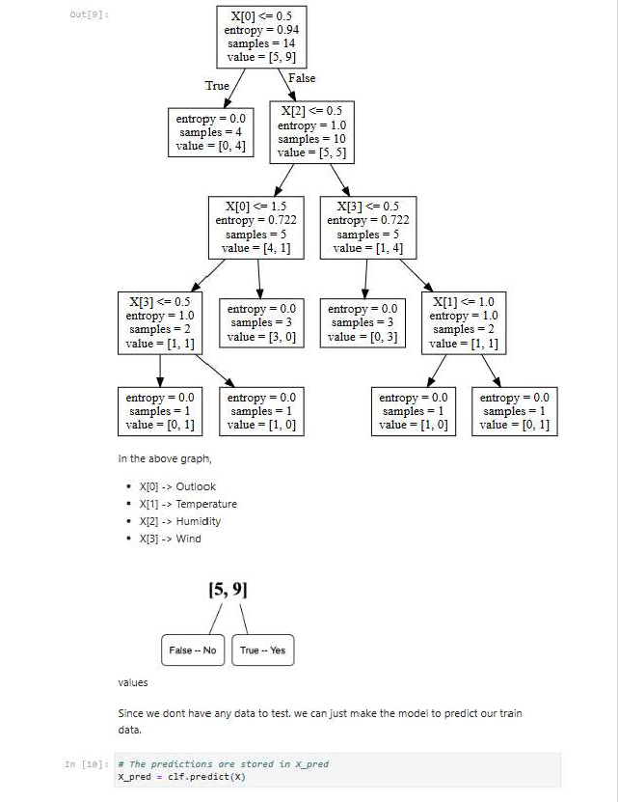



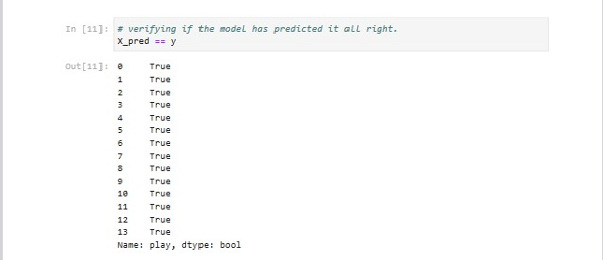



**PRACTICAL NO: 4**

**AIM: Feed Forward Back propagation Neural Network**

* Implement the Feed Forward Back propagation algorithm to train a neural network
* Use a given dataset to train the neural network for a specific task

**Requirement: Python IDLE Code:**

from doctest import OutputChecker import numpy as np

class NeuralNetwork():

def init (self):

np.random.seed() self.synaptic_weights=2*np.random.random((3,1))-1 def sigmoid(self,x):

return 1/(1+np.exp(-x))

def sigmoid_derivative(self,x):

return x*(1-x)

def train(self,training_inputs,training_outputs,training_iterations): for iteration in range(training_iterations): output=self.think(training_inputs)

error = training_outputs-output adjustments=np.dot(training_inputs.T,error*self.sigmoid_derivative(output)) self.synaptic_weights +=adjustments

def think(self,inputs): inputs=inputs.astype(float)

output=self.sigmoid(np.dot(inputs,self.synaptic_weights)) return output

if name == " main ":

#initializing the neuron class neural_network = NeuralNetwork()

print("Beginning Randomly Generated Weights: ") print(neural_network.synaptic_weights)

#training data consisting of 4 examples--3 input values and 1 output training_inputs = np.array([[0,0,1],

[1,1,1],

[1,0,1],

[0,1,1]])



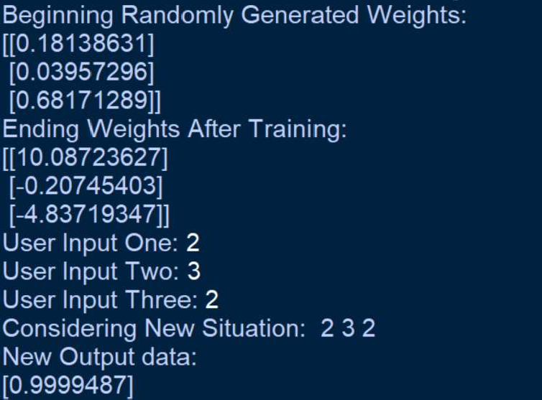

training_outputs = np.array([[0,1,1,0]]).T #training taking place

neural_network.train(training_inputs, training_outputs, 15000) print("Ending Weights After Training: ") print(neural_network.synaptic_weights)

user_input_one = str(input("User Input One: ")) user_input_two = str(input("User Input Two: ")) user_input_three = str(input("User Input Three: "))

print("Considering New Situation: ", user_input_one, user_input_two, user_input_three) print("New Output data: ")

print(neural_network.think(np.array([user_input_one, user_input_two, user_input_three])))

Output:



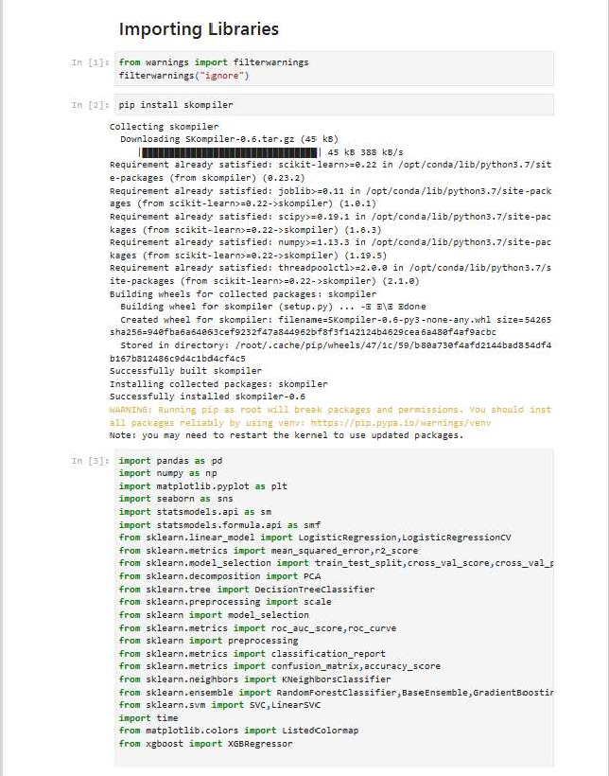

**PRACTICAL NO: 5**

**Aim: Implement the SVM algorithm for binary classification. Train a SVM Model using the given dataset. Evaluate the performance on test data and analyze the results.**



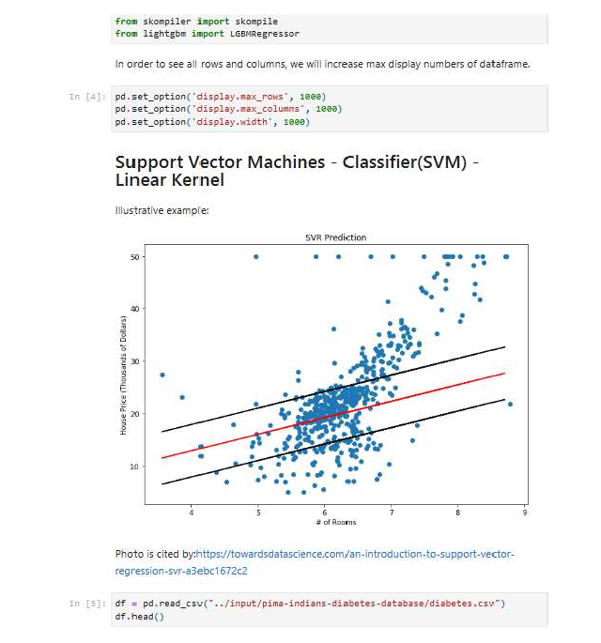



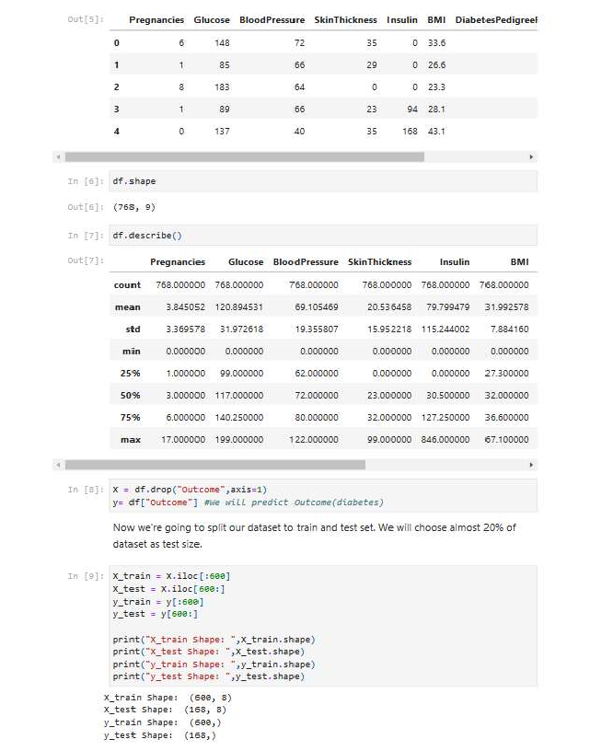



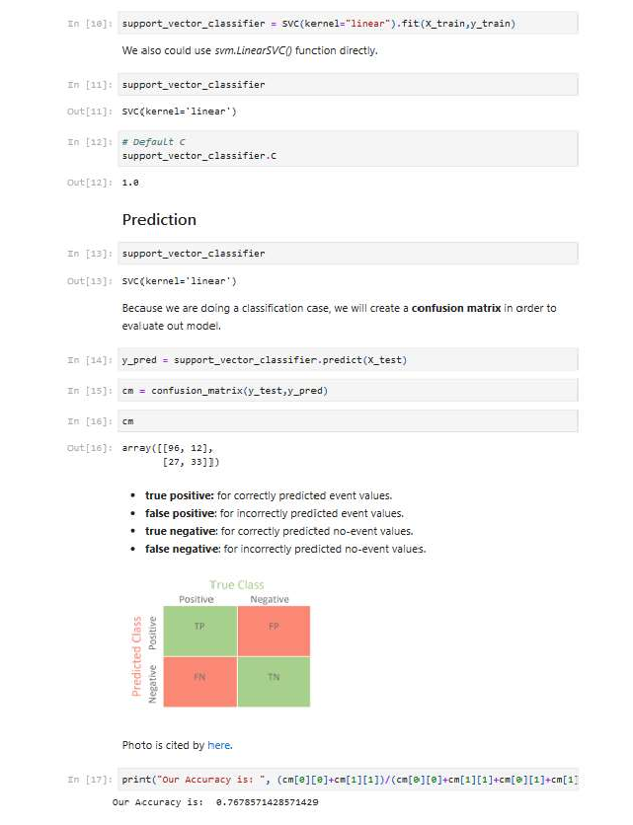



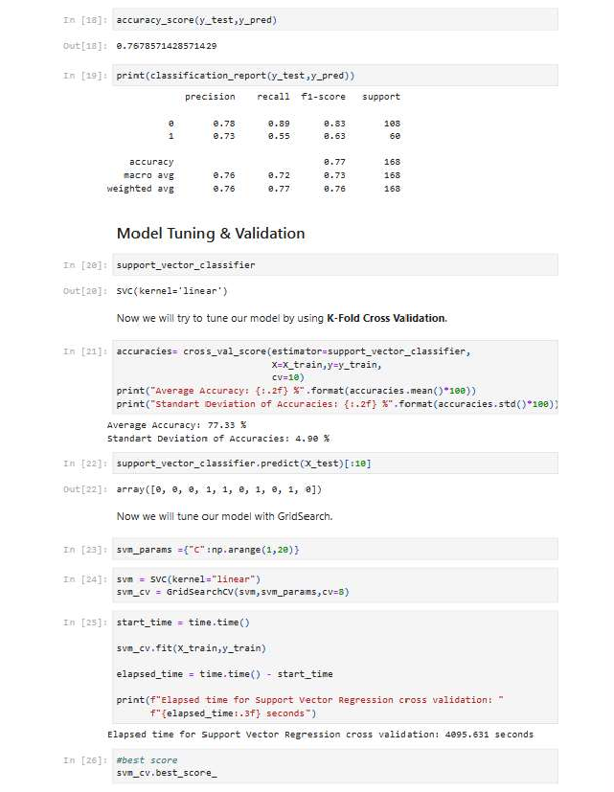



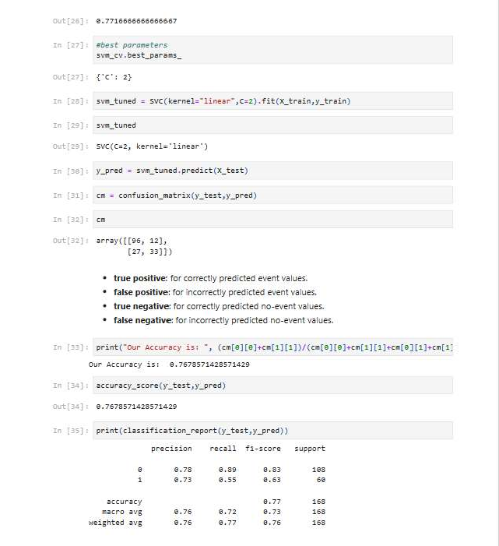

**PRACTICAL NO: 6**

**AIM:** Adaboost Ensemble Learning

* Implement the Adaboost algorithm to create an ensemble of weak classifiers.
* Train the ensemble model on a given dataset and evaluate its performance
* Compare the results with individual weak classifiers

**Requirement:**

**Code:**

import pandas

from sklearn import model_selection

from sklearn.ensemble import AdaBoostClassifier

url = "https://raw.githubusercontent.com/jbrownlee/Datasets/master/pima-indians- diabetes.data.csv"

names = ['preg', 'plas', 'pres', 'skin', 'test', 'mass', 'pedi', 'age', 'class'] dataframe = pandas.read_csv(url, names=names)

array = dataframe.values X = array[:,0:8]

Y = array[:,8] seed = 7

num_trees = 30

#kfold makes trees with split number.

#kfold = model_selection.KFold(n_splits=10, random_state=seed) #n_estimators : This is the number of trees you want to build before predictions.

#Higher number of trees give you better voting optionsand perfomance performance model = AdaBoostClassifier(n_estimators=num_trees, random_state=seed) #cross_val_score method is used to calculate the accuracy of model sliced into x, y #cross validator cv is optional cv=kfold

results = model_selection.cross_val_score(model, X, Y) print(results.mean())

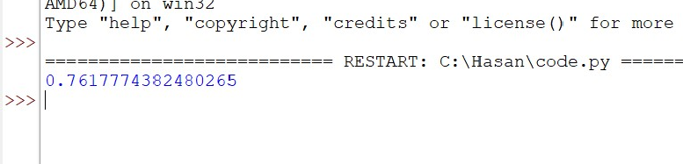**Output**:



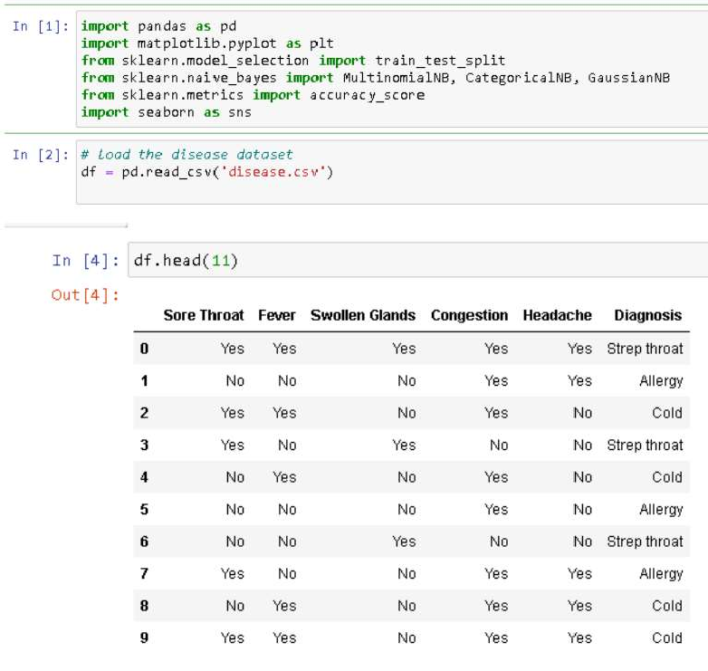

**PRACTICAL NO: 7**

**AIM:** Naive Bayes' Classifier

* Implement the Naive Bayes algorithm for classification.
* Trin a Naive Bayes' model using a given dataset and calculate class probabilities.
* Evaluate the accuracy of the model on test data and analyze the results.

**Requirement:** disease dataset

**Code:**



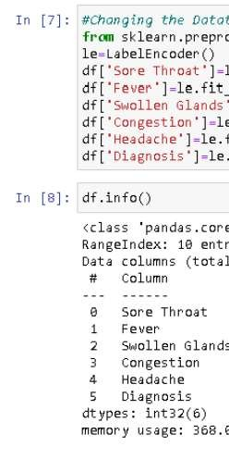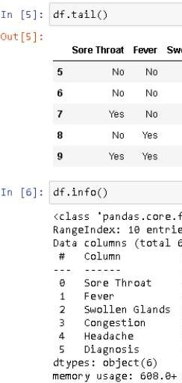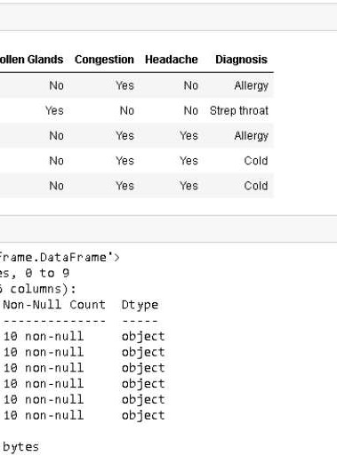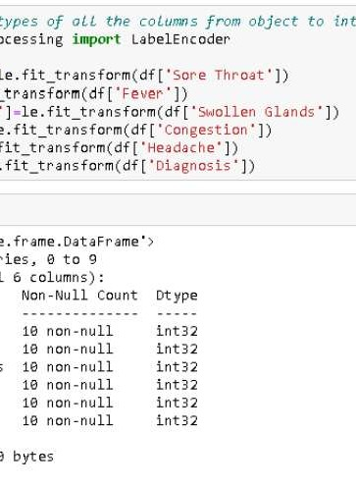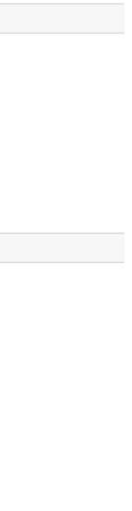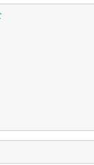



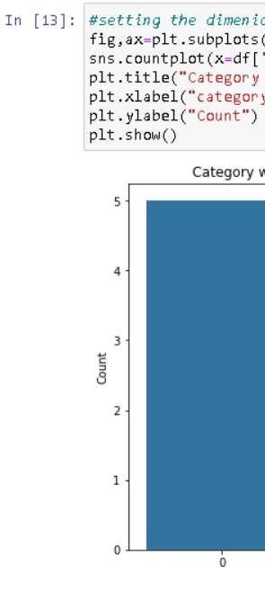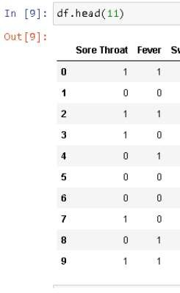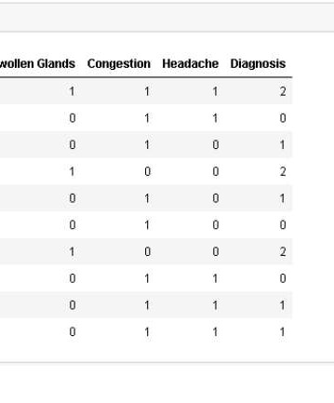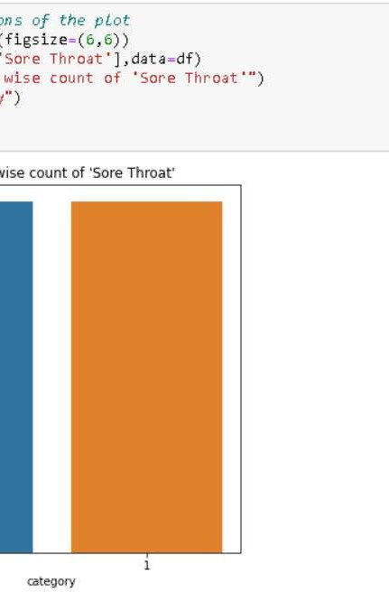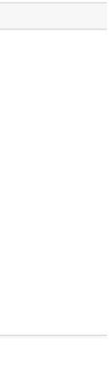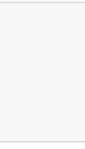



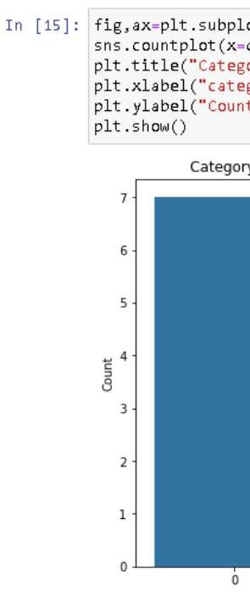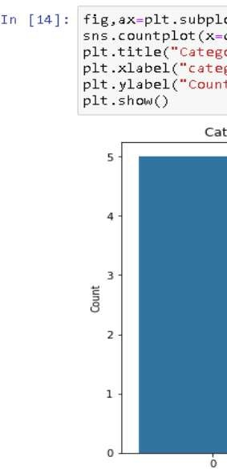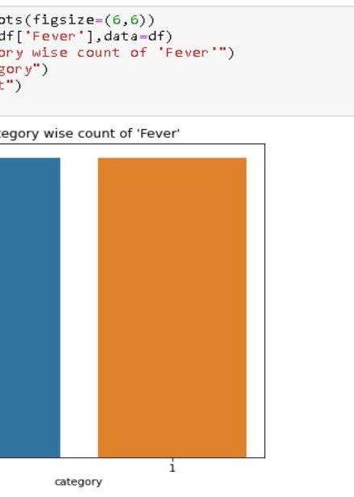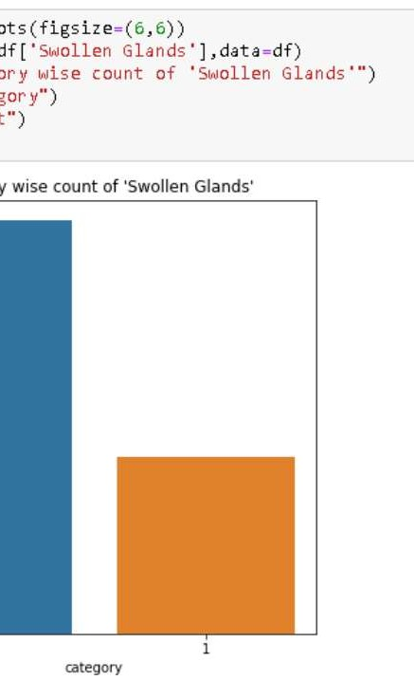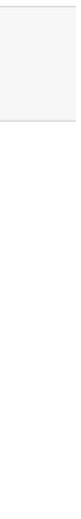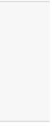



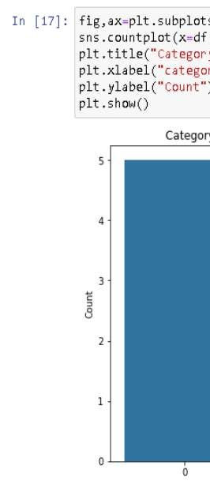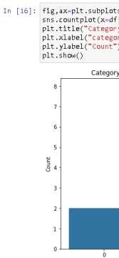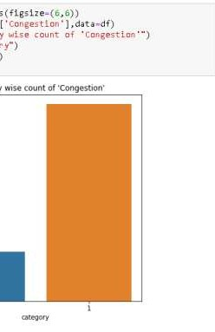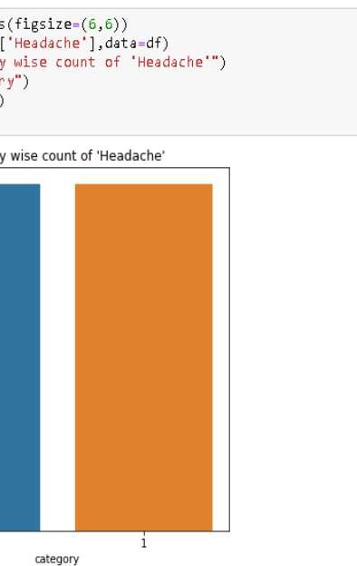



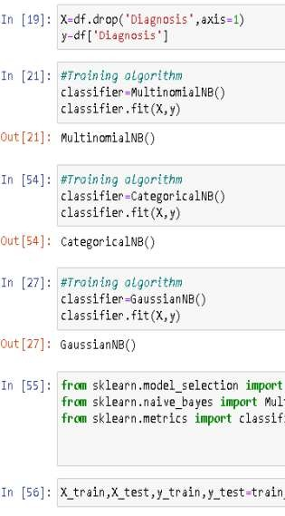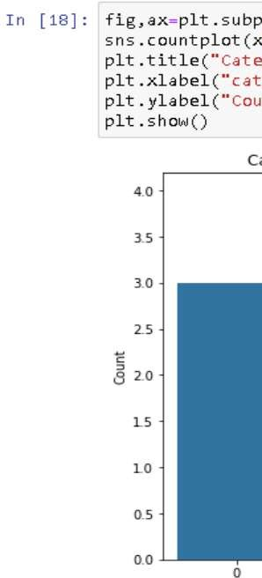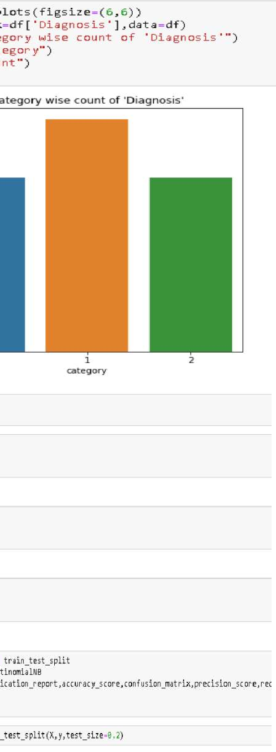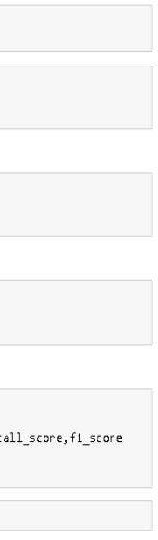



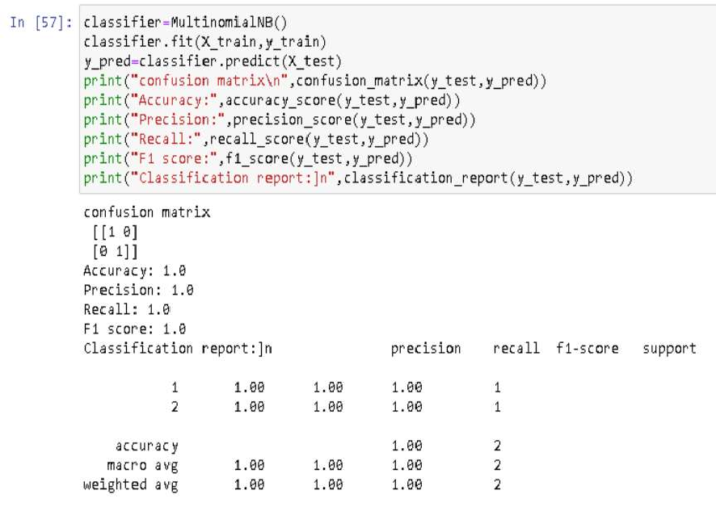



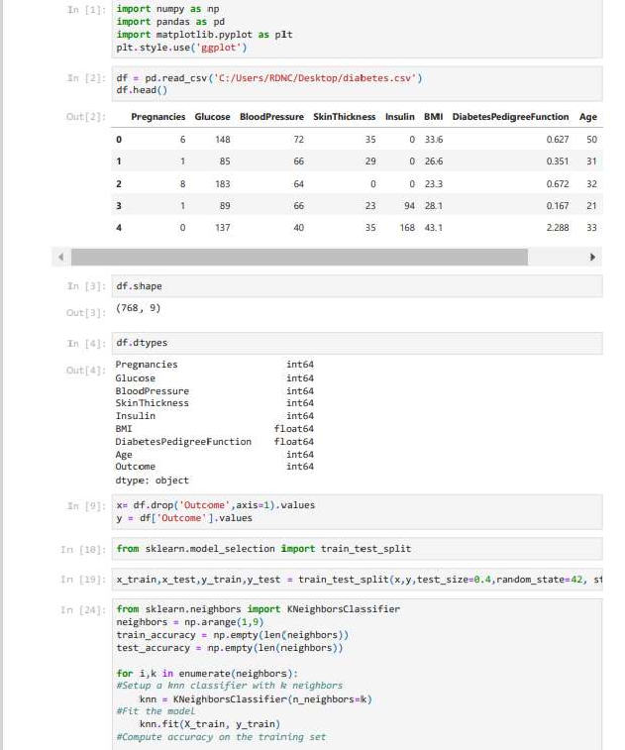

**PRACTICAL NO: 8**

**Aim:- Implement the K-NN Algorithm for classification or regression.**

**Apply K-NN Algorithm on the given dataset & predict the class or value for test data.**



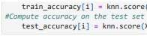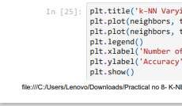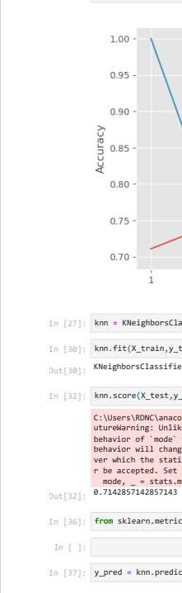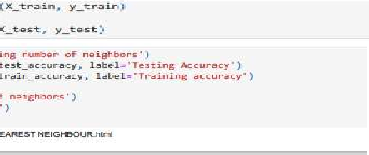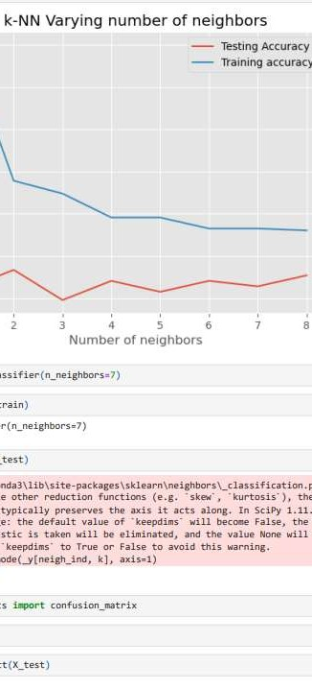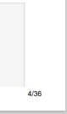



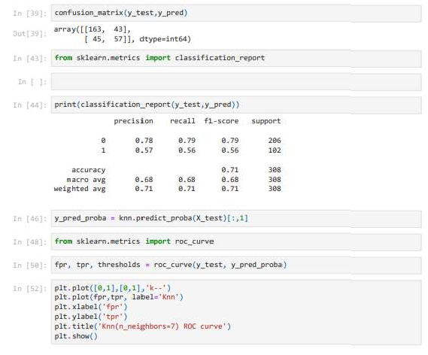



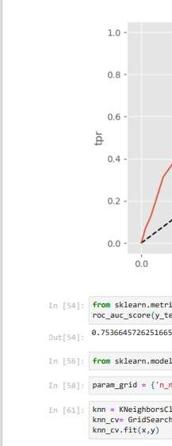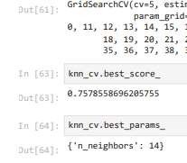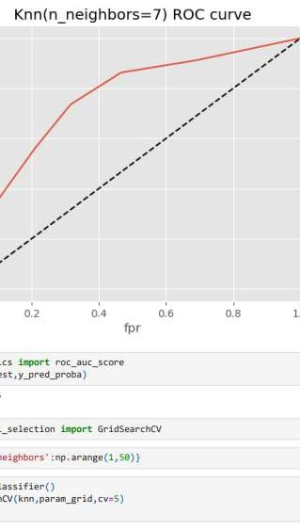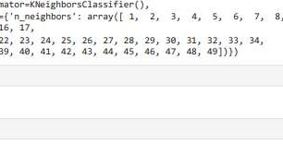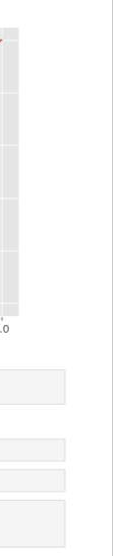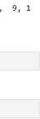



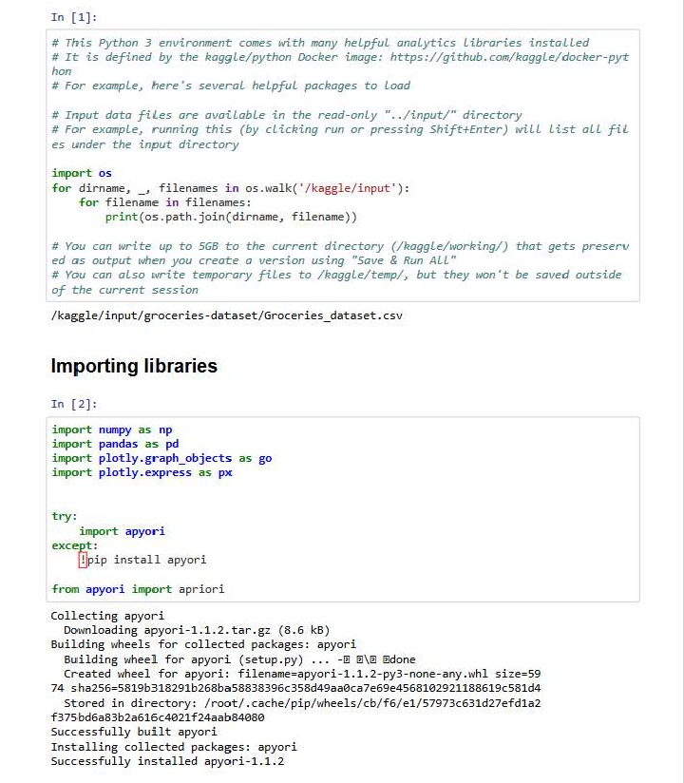

**PRACTICAL No: 9**

**Aim: Implement the Association Rule Mining algorithm (e.g. Apriori) to find frequent dataset. Generate association rules from the frequent item set and calculate their support.**



